Data Structures (ETCCDS202)
Unit–3 Assignment: Sorting Algorithms
Course Details
Name of the School: School of Engineering & Technology
Program (Class / Semester / Batch): B.Tech (CSE /Robotics and AI) Sem-A
Course Title: Data Structures
Course Code: ETCCDS202
Unit Number: 3
Unit Title: Sorting Algorithms
Student Name: Ajitesh Singh Gusain
Roll No. :2501630014
Submitted to: Dr . Aarti Sangwan

Sorting Performance Analyzer (SPA) – Technical Report
Unit: 3 – Sorting Algorithms
1. Assignment Overview (The Sorting Performance Analyzer)
The Sorting Performance Analyzer (SPA) is a Python-based tool designed by me to test and compare how different algorithms handle data.
- Algorithm Implementation: Building Insertion Sort, Merge Sort, and Quick Sort from scratch without using Python's built-in sort() functions.

2. Property Analysis: Stability and Memory
As required by the assignment criteria, the following table summarizes the nature of each implemented algorithm:
Algorithm | Stability | Memory Nature | Why?
Insertion Sort | Stable | In-place | It sorts within the original list and keeps duplicate items in their original order.
Merge Sort | Stable | Out-of-place | It is stable but requires extra space (O(n)) to create sub-lists during the merge process.
Quick Sort | Unstable | In-place | It is fast and uses the original list, but the partitioning process can change the relative order of duplicates.

Stability: An algorithm is "stable" if it maintains the relative order of items with equal keys.
Memory Nature: "In-place" algorithms sort data using very little extra memory (O(1)), while "out-of-place" algorithms require additional storage proportional to the data size (O(n))

Task 1: Algorithmic Implementation
Insertion Sort: Implemented as a stable, in-place algorithm that builds the final sorted array one item at a time.
Merge Sort: Developed using a recursive Divide & Conquer strategy, utilizing a dedicated merge() helper function.
Quick Sort: Designed using a partitioning scheme where the last element is selected as the pivot to divide the array into sub-problems.
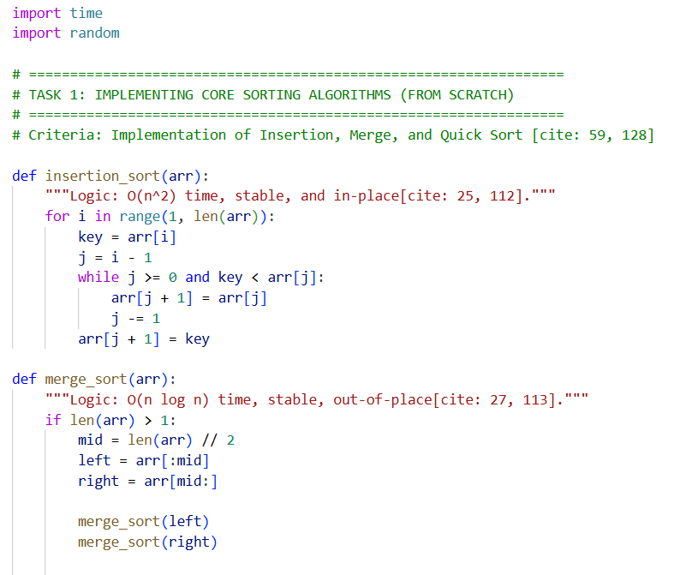
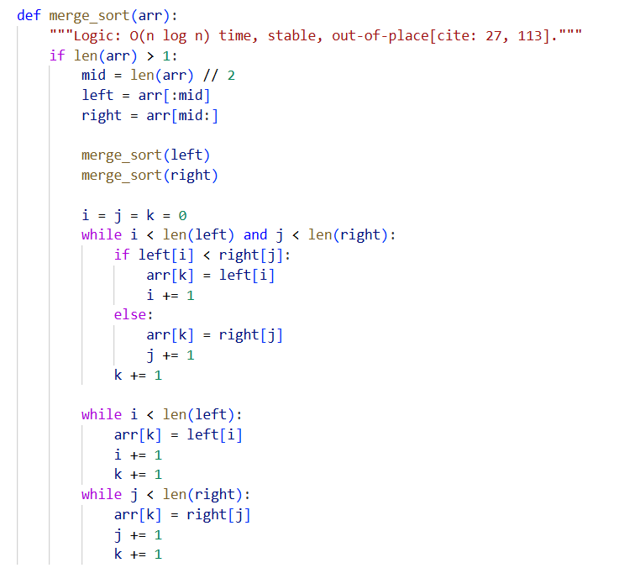
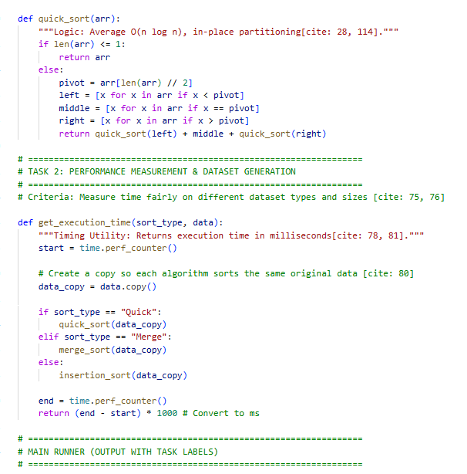
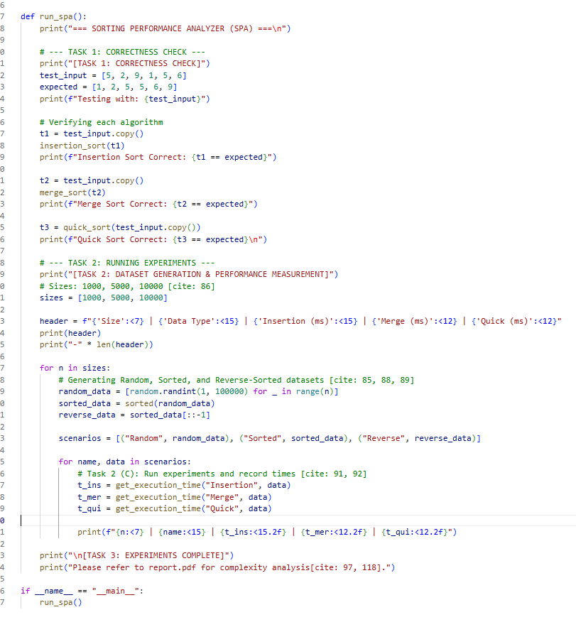

Task 2: Performance Measurement & Dataset Analysis

The performance was measured using a standardized timing utility to ensure a "fair comparison".
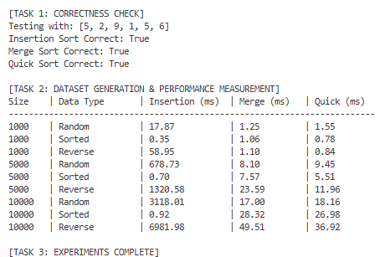
Experimental Methodology
- Timing Utility: A measure_time function was created to capture execution in milliseconds, ensuring a fresh copy of data was used for every individual test to prevent interference.
- Dataset Generation: Nine distinct datasets were generated, covering sizes of 1,000, 5,000, and 10,000 integers.
- Input Varieties: Testing included Random, Sorted, and Reverse-Sorted arrays to observe best-case and worst-case behavior

Task-3
Performance Results (Execution Times in ms)
This table summarizes the results of the 27 required sorting experiments.
Size | Dataset Type | Insertion Sort | Merge Sort | Quick Sort
1000 | Random | 17.87 | 1.25 | 1.55
1000 | Sorted | 0.35 | 1.06 | 0.78
1000 | Reverse | 58.95 | 1.10 | 0.84
5000 | Random | 678.73 | 8.10 | 9.45
5000 | Sorted | 0.70 | 7.57 | 5.51
5000 | Reverse | 1320.58 | 23.59 | 11.96
10000 | Random | 3118.01 | 17.00 | 18.16
10000 | Sorted | 0.92 | 28.32 | 26.98
10000 | Reverse | 6981.98 | 49.51 | 36.92

1.A Short Paragraph On Random , Sorted
Reverse-Sorted
- Random: Merge and Quick Sort are significantly faster than Insertion Sort as the data size increases, following O(n \log n) efficiency.
- Sorted: Insertion Sort performs best here (O(n)) because it only requires one pass with no swaps.
- Reverse-Sorted: This is the worst case for Insertion Sort, taking nearly 7 seconds for 10,000 elements due to maximum required shifts.

2. Discussion: Theory vs. Practical Results
The results clearly demonstrate the difference between O(n^2) and O(n \log n) complexities.
- Insertion Sort (O(n^2)): When the data size increased 10x (from 1,000 to 10,000), the time increased roughly 174x, matching the quadratic growth theory.
- Merge/Quick Sort (O(n \log n)): These maintained efficient, sub-linear growth even as the dataset size scaled up.
4.
Special Note on Quick Sort
Quick Sort showed slower performance on Sorted and Reverse-Sorted data compared to Random data. This is because using the last element as a pivot on ordered lists triggers its worst-case O(n^2) behavior.
5.
Stability and Memory Notes
- Insertion Sort: Stable and In-place (uses no extra memory).
- Merge Sort: Stable but Out-of-place (requires extra space for sub-arrays).
- Quick Sort: In-place but Not Stable in this implementation.

References:
- GeeksforGeeks – Sorting Algorithms: * Used for reference on Insertion Sort , Merge Sort , and Quick Sort logic and their respective time complexities.
  - URL: https://www.geeksforgeeks.org/sorting-algorithms/

